Charleen Tan

HSA 10-5 Economic of Oil and Energy

28 April, 2016

Prospects of Solar Water Heating in China

With the dramatic economic growth in China, the consumption and production of electricity increased significantly over the two decades.[1] However, China does not use a clean source of energy to produce electricity, instead, China choses the dirty and cheap energy source, coal. There are many negative aspects of the usage of coal. One of them is the environmental cost of coal. As the environmental issues get worsen in China, the Chinese government have the renewable energy policies that promote the implementation of renewable energy source such as solar and wind.

1. Background
   1. What is solar energy?

Solar energy is a kind of energy from the sun that is converted into electric or thermal.[2] Solar energy is renewable and abundant. There are solar cells, photovoltaic, that converts solar energy into electricity by exciting electrons in the semiconductor. There are also solar thermal energies that uses the heat directly instead of the light.

* 1. Solar energy in China

The solar energy is abundant in China where the chance that have low resource is very low. As shown in the picture, 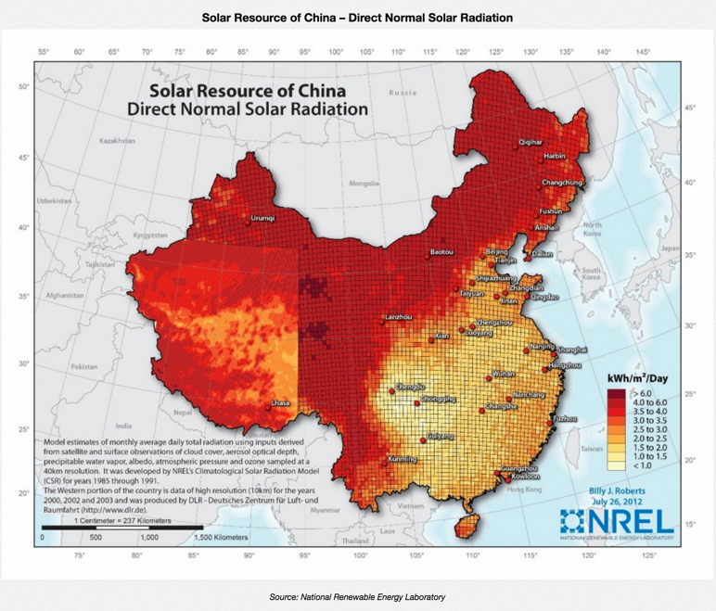

The solar resource of China is abundant and they are all in the rural area of China where the smog is not dense. Therefore, a lot of solar cells are implemented in those areas where the smog is not severe enough to block the sunlight. Because of the abundant solar energy, the solar PV installations are 10.6 GW which is nearly 25% of the total solar PV installation in the world 38.7 GW[3]. As shown there are growths in the solar PV installations were photovoltaics convert sunlight into electricity. However, it is not significant enough to reduce the coal consumption in China.

* 1. Disadvantage of Solar Energy

Although Chinese government and the policies are promoting the installations of solar cells, the actual cost of solar cells is expensive. As shown in the graph, 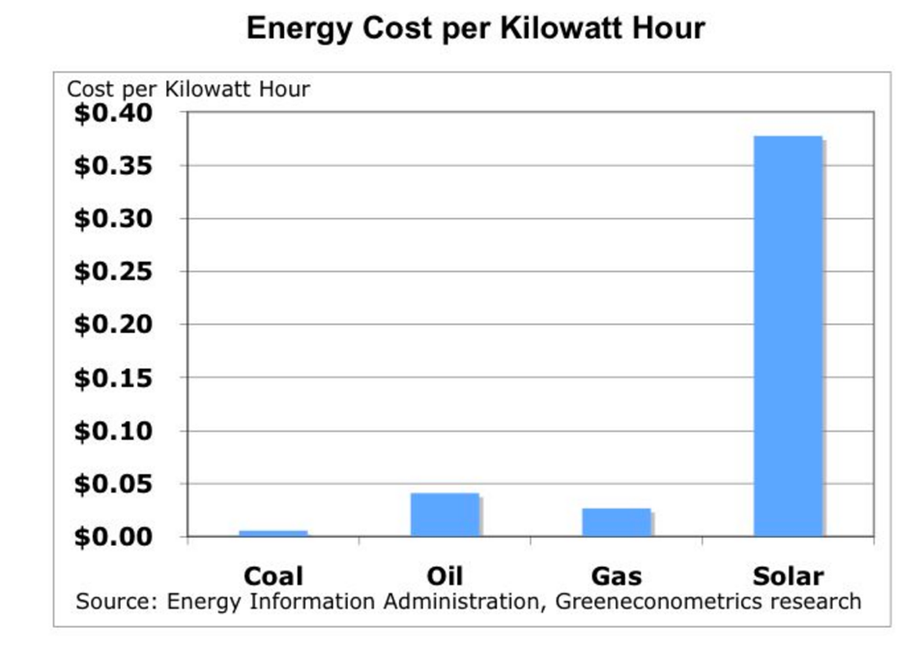[4]

Cost per kilowatt Hour of solar energy is significantly higher than that of coal, oil and gas all combined. Therefore, solar energy is an expensive source of energy. However, the main reason of solar energy being expensive is the solar panels themselves.[5] That is only one-time investment, so the cost would eventually be even out as the time gone by. Therefore, as long as the people are able to afford the initial cost of solar energy. Then the cost would not be that significant compared with other source of energy.

Cost of coal is the cheapest among all the energy sources, but the CO2 emissions are the highest among the all. The environmental cost of coal is unable to be solved with money. As we see the environmental issues in China are causing not only environmental changes, acid rain and smog, but also are affecting people’s health that leads to cardiovascular and lung issues. The health problems are unable to be solved with money. Even though, the solar energy has the highest cost, the environmental cost is minimal with nearly no carbon and greenhouse emissions.

1. Solar Water Heating System
   1. What is Solar Water Heating System?

Solar water heating is to use sun’s thermal energy to heat water using a solar thermal collector. One type of the solar water heating system is evacuated tube. Comparing to the solar cells’ efficiency, 10%- 18%, it can have up to 50%- 70% efficiency.

* 1. Why?

20% of electricity used in homes by end uses is for water heating. As shown in the chart, 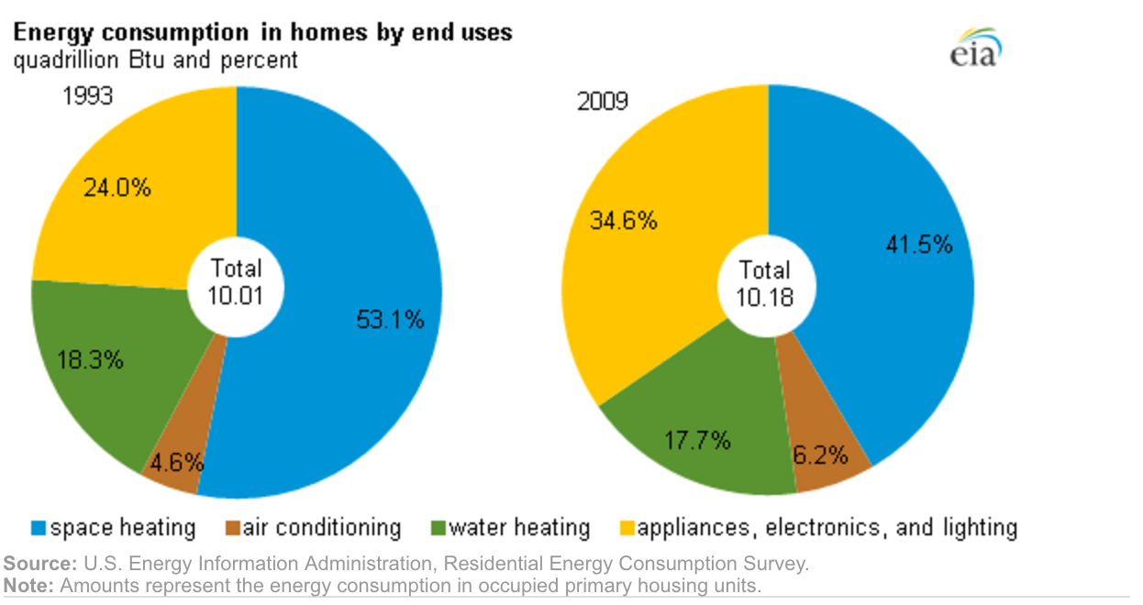

The electricity used to water heating has not been decreased from 1993 to 2009. If you could replace this use of energy with solar water heating, around 20% of the electricity could be saved. Maybe can be used for other purposes, or maybe can even decrease the production and consumption of coal which China heavily rely on. Although this is not a big scale movement, the small steps can reduce residential utility costs and the specific amount of energy can be used for other purposes rather than to heat water purely which can be substituted by the renewable energy, solar.

* 1. Evacuated tube

There are a lot of types of solar water heating systems. One of them is evacuated tubes. Solar water heating system in China is cheaper than in Western countries because the labor is cheaper. As shown in the graph, 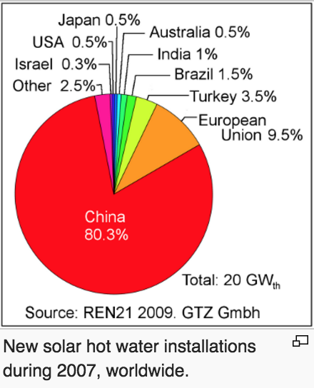[6]

China has the highest percentage of the solar hot water installations during 2007. However, population is huge in China, the increase in the installations is not significant compared to the overall population and electricity usage in China.

Usually, evacuated tube solar water heating systems are mounted on top of the roof and require a pump to make the water flow in the apartment. This design makes the house less attractive in appearance because of the huge water heating system on the roof. However, there is the new kind solar water heating, evacuated tubes that can mounted as fences. In this picture, 

The fences are next to a swimming pool and it does not affect the appearance that much. All the hot water that the swimming pool needed can be obtain from this system. We can now move on the analyze the actual cost of this implementations to see if this is a feasible plan.

1. Cost of the evacuated tubes

The costs of the evacuated tubes are mainly the installation fee, and the its maintenance. There is merely no cost of heating the actual water because it utilizes the solar thermal to heat the water.

* 1. Evacuated tube cost

Each evacuated water heater tube costs about $40 and a system of the solar water heating for 4-5 people usually needs 30 tubes. From the calculation, the tubes cost around $1200. Adding the cost of the installation fee, the whole system costs is around $2000.

* 1. Electricity heating water

Average electricity bill is around $100/ month. As we previously mentioned, around 20% of the electricity is used for water heating. Therefore, $20 is saved per household. Given the amount of population in China, the money that can be saved is significant.

* 1. Energy saved

The amount of CO2 emissions due to coal consumption is increasing dramatically. 153.7 million short tons of coal is consumed for heat plants.[7]

1. Energy Information Administration and Short-Term Energy Outlook, May 2015
2. http://www.seia.org/about/solar-energy
3. http://www.eos-intelligence.com/perspectives/?p=1331
4. http://greenecon.net/understanding-the-cost-of-solar-energy/energy_economics.html
5. http://energyinformative.org/solar-panels-cost/
6. REN21 2009
7. http://www.iea.org/stats/coaldata.asp?COUNTRY_CODE=CN